|  |  |
| --- | --- |
| **Summary Statistics** | **n = 75** |
|  |  |
| **Female CVD age adjusted mortality rate (per 100 000 population) Source: Global Burden of Disease 2019** |  |
| min | 62 |
| max | 1024.9 |
| median (IQR) | 241.30 (128.06, 345.30) |
| missing | 0 |
|  |  |
| **Male CVD age adjusted mortality rate (per 100 000 population) Source: Global Burden of Disease 2019** |  |
| min | 106.8 |
| max | 1205.2 |
| median (IQR) | 278.05 (180.32, 428.51) |
| missing | 0 |
|  |  |
| **Population CVD age adjusted mortality rate (per 100 000 population) Source: Global Burden of Disease 2019** |  |
| min | 82.6 |
| max | 1107 |
| median (IQR) | 262.98 (155.95, 372.59) |
| missing | 0 |
|  |  |
| **Ratio of female to male CVD mortality rates Source: Global Burden of Disease 2019** |  |
| min | 0.5 |
| max | 1.6 |
| median (IQR) | 0.72 (0.67, 0.85) |
| missing | 0 |
|  |  |
| **Female life expectancy at birth Source: World Health Observatory** |  |
| min | 61 |
| max | 86.4 |
| median (IQR) | 78.60 (74.45, 82.60) |
| missing | 0 |
|  |  |
| **Male life expectancy at birth Source: World Health Observatory** |  |
| min | 55.7 |
| max | 80.7 |
| median (IQR) | 73.00 (67.90, 77.60) |
| missing | 0 |
|  |  |
| **GSNI index 2 or more bias Source: Gender Social Norms Index** |  |
| min | 7.4 |
| max | 98.1 |
| median (IQR) | 68.56 (41.94, 86.33) |
| missing | 0 |
|  |  |
| **Year of Index Collection Source: Gender Social Norms Index** |  |
| 2005-2009 | 18 (24) |
| 2010-2014 | 57 (76) |
|  |  |
| **Physicians per 1000 population Source: World Bank** |  |
| min | 0 |
| max | 5 |
| median (IQR) | 71; 2.30 (1.29, 3.22) |
| missing | 4 |
|  |  |
| **GDP per capita Source: World Bank** |  |
| min | 566.9 |
| max | 97019.2 |
| median (IQR) | 68; 9181 (4094, 31623) |
| missing | 7 |
|  |  |
| **Maternal Mortality Ratio Source: World Bank** |  |
| min | 2 |
| max | 943 |
| median (IQR) | 70; 25.50 (10.25, 82.75) |
| missing | 5 |
|  |  |
| **Mean years of schooling Source: Our World In Data** |  |
| min | 1.4 |
| max | 14 |
| median (IQR) | 69; 10.10 (7.60, 11.80) |
| missing | 6 |

***Table 1.*** Summary statistics. IQR – inter-quartile range

**Figure 1. A.** Scatter plot of GSNI2 and female CVD mortality rate. **B.** Scatter plot of GSNI2 and male CVD mortality rate. **C.** Scatter plot of GSNI2 and CVD mortality rate. **D.** Scatter plot of GSNI2 and female to male ratio of CVD mortality rates.

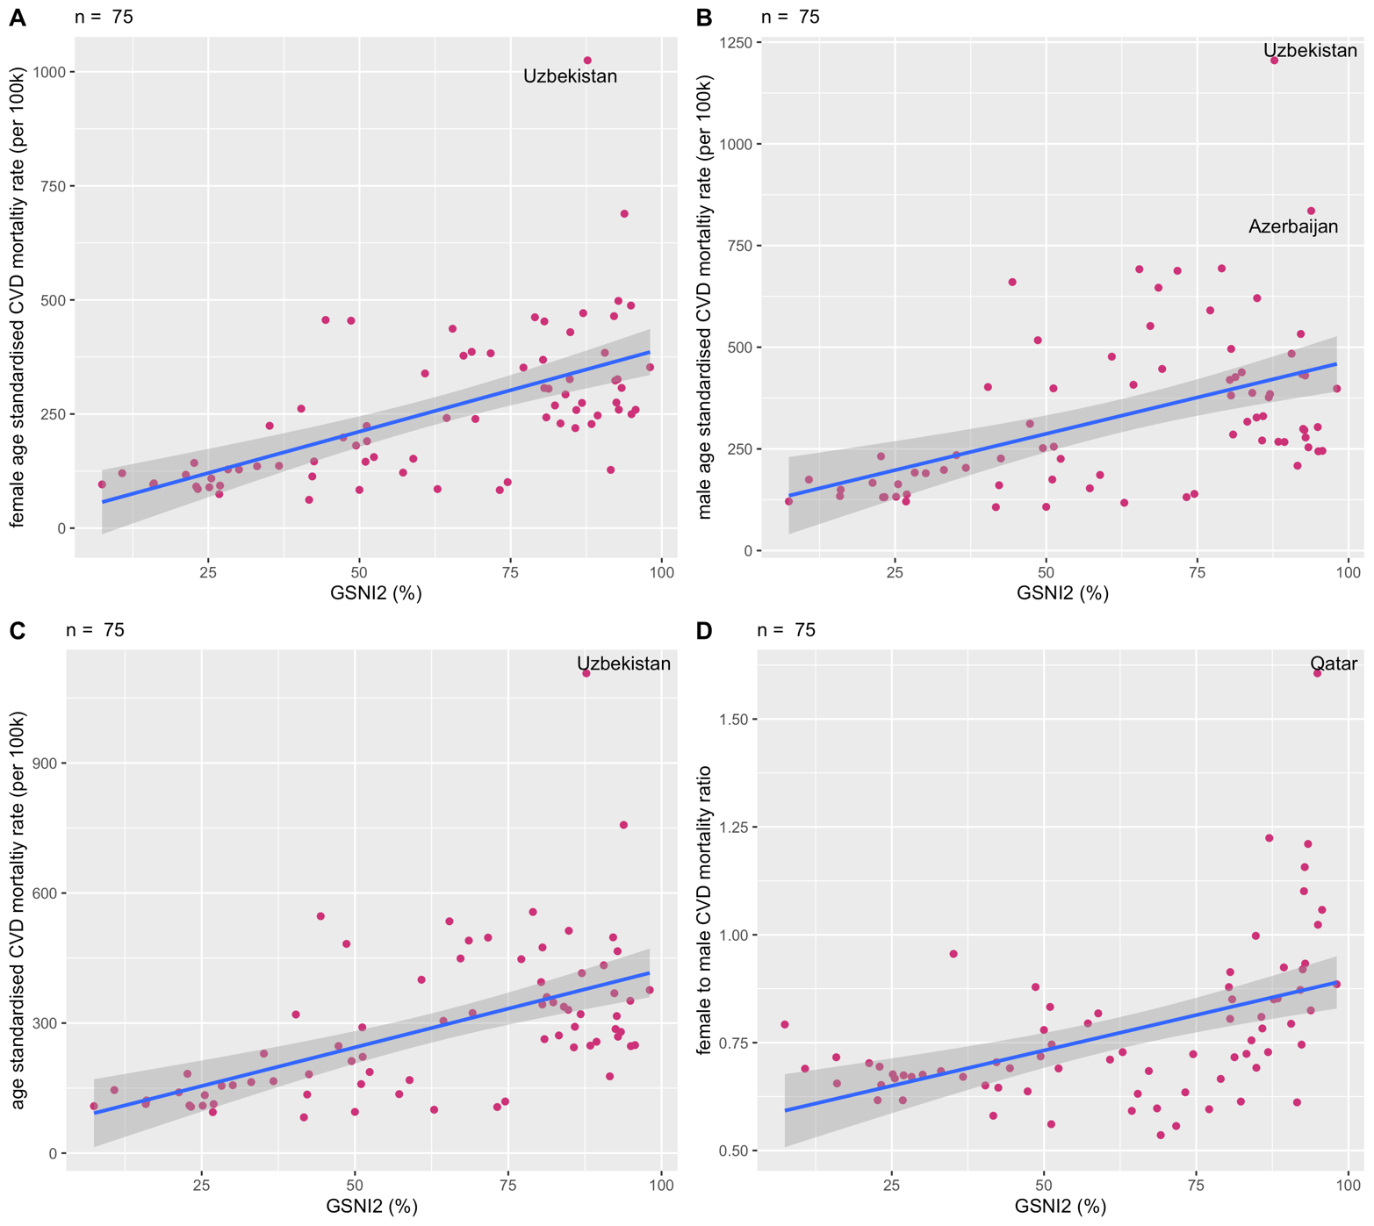

**Figure 2. A.** Scatter plot of GSNI2 and female life expectancy at birth. **B.** Scatter plot of GSNI2 and male life expectancy at birth.

|  |  |
| --- | --- |
| ***Table 1. Suggested MPH learning outcomes per module*** Epidemiology and Statistics (Semester 1) | 1.1, 1.3, 1.4, 1.5, 1.6, 1.8  8.1, 8.2, 8.4 |
| Health Improvement (Semester 1) | 1.3, 1.5, 1.6, 1.7, 2.1, 2.2  3.1, 3.2, 3.3, 3.5, 3.7, 5.4, 5.6  7.3 |
| Health Policy, Governance and Economics (Semester 1) | 1.3, 1.4, 1.5, 1.6, 2.1, 2.2, 3.1, 3.2, 3.3, 3.7, 4.2, 4.3, 4.5, 4.6, 7.1, 7.2, 7.3, 7.5, 7.6 |
| Health and Society (Semester 1) | 1.3, 1.4, 2.1, 2.2, 3.1, 8.4 |
| An introduction to Qualitative Research | 1.1, 1.2, 1.3, 1.4, 8.4, 8.6, 8.7  9.10 |
| Health Inequalities: Evidence and Policy | 1.1, 1.3, 1.4, 1.5, 1.7, 2.1, 2.2, 2.4  3.5, 3.7, 4.2, 4.5, 4.7, 4.8, 5.2, 8.2  9.7 |
| Health Protection | 1.1, 1.3, 1.4, 1.5, 2.1, 2.2, 2.3, 2.4  3.2, 3.3, 3.5, 3.7, 4.2, 4.3, 4.5, 4.7, 4.9, 6.1, 6.2, 6.3, 6.6, 6.7, 6.8, 7.3  8.2, 9.1, 9.3, 9.7 |
| Epidemiology and Statistics for PH Module 2 | 1.1, 1.3, 1.4, 1.5, 2.1, 2.2, 2.3, 2.4, 2.5, 2.6, 7.1, 8.1, 8.2, 8.3, 8.4, 8.7 |
| Dissertation | 1.1, 1.3, 1.4, 1.5, 1.8, 2.1, 2.2, 2.3, 2.5, 3.1, 8.1, 8.2, 8.3, 8.5, 8.6, 8.7, 8.8, |

In the univariable models, higher levels of gender bias as measured by the GSNI2 were statistically significantly associated with higher female CVD mortality rates (𝛽 3.63, 95% CIs 2.48 to 4.78), male CVD mortality rates (𝛽 3.57, 95% CIs 2.03 to 5.12) and population CVD mortality rates (𝛽 3.57, 95% CIs 2.29 to 4.85). The statistically significant association remained after adjusting for physicians per 1000 population, mean years of schooling, GDP per capita and GSNI data collection period (*table 2 & 3*). The multivariable model results indicate that for every 1% greater proportion of the population who hold 2 or more gender biases, the female CVD mortality rate was higher by 4.86 per 100 000 (95% CI 3.21 to 6.51), male CVD mortality rate higher by 5.28 per 100 000 (95% CI 3.42 to 7.15) and the population CVD mortality rate was higher by 4.89 per 100 000 (95% CI 3.18 to 6.60). In the univariable model GSNI2 was statistically significantly associated with female to male CVD mortality ratio (𝛽 0.003, 95% CIs 0.002 to 0.005). This relationship was not significant within the multivariable model (𝛽 0.001, 95% CIs -0.001 to 0.003). Qatar was identified as an influencial outlier within this model and was removed.

*Table 4* demonstrates the model results for the life expectancy outcomes. In the univariable analysis, higher levels of gender bias as measured by the GSNI2 were statistically significantly associated with lower female life expectancy (𝛽 -0.16, 95% CIs -0.20 to -0.12) and lower male life expectancy (𝛽 -0.15, 95% CIs -0.20 to -0.11). This relationship remained statistically significant after controlling for physicians per 1000 population, mean years of schooling, GDP per capita and GSNI data collection period. MMR was also included within the female life expectancy model. Within the life expectancy multivariable models, the physicians per 1000 and GDP per capita variables were log transformed due to their relationship with the outcome variable. In the final life expectancy model the coefficient indicates that for every 1% greater proportion in the GSNI2, female life expectancy was lower by 0.07 years (25.6 days) (95% CI -0.11 to -0.04) and male life expectancy was lower by 0.05 years (18.3 days) (95% CI -0.10 to -0.01).

The sensitivity analysis made use of data from 2017 and 2019 with no change in direction of association between each outcome variable and GSNI2. The only change in statistical significance compared to the primary analyisis was the multivariable male life expectancy model in which male life expectancy was not found to be statistically significantly associated with GSNI2 (*supplementary appendix*).

|  |
| --- |
|  |
| |  |  |  |  |  | | --- | --- | --- | --- | --- | |  | | | | | |  | | | | | |  | Dependent variable: | | | | |  |  | | | | |  | female CVD mortality | | male CVD mortality | | |  | (1) | (2) | (3) | (4) | |  | | | | | | constant | 30.04 (39.25) | -133.15 (94.46) | 108.45* (52.87) | -184.13 (104.74) | | GSNI2 | 3.63*** (0.58) | 4.86*** (0.84) | 3.57*** (0.78) | 5.28*** (0.93) | | physicians per 1000 |  | 32.31 (19.26) |  | 70.59** (21.35) | | mean years of schooling |  | 13.75 (9.37) |  | 21.71* (10.39) | | GDP per capita |  | -0.002* (0.001) |  | -0.004*** (0.001) | | GSNI data collection period 2010-2014 |  | -97.89* (40.74) |  | -127.18** (45.17) | |  | | | | | | R2 | 0.35 | 0.49 | 0.23 | 0.56 | | Adjusted R2 | 0.34 | 0.44 | 0.21 | 0.53 | | F Statistic | 39.68*** (df = 1; 73) | 11.54*** (df = 5; 61) | 21.23*** (df = 1; 73) | 15.62*** (df = 5; 61) | |  | | | | | |  | * p<0.05, **p<0.01,***p<0.001 | | | |   ***Table 2.*** Results of univariable and multivariable regression models for the female and male CVD mortality outcomes. Numbers in brackets are standard errors. |

|  |  |  |  |  |
| --- | --- | --- | --- | --- |
|  | | | | |
|  | Dependent variable: | | | |
|  |  | | | |
|  | CVD mortality | | female to male CVD mortality ratio | |
|  | (1) | (2) | (3) | (4) |
|  | | | | |
| constant | 65.58 (43.71) | -140.69 (95.92) | 0.57*** (0.05) | 0.90*** (0.09) |
| GSNI2 | 3.57*** (0.64) | 4.89*** (0.85) | 0.003*** (0.001) | 0.001 (0.001) |
| physicians per 1000 |  | 47.45* (19.55) |  | -0.04* (0.02) |
| mean years of schooling |  | 17.25 (9.52) |  | -0.01 (0.01) |
| GDP per capita |  | -0.003** (0.001) |  | -0.0000 (0.0000) |
| GSNI data collection period 2010-2014 |  | -110.79** (41.36) |  | -0.03 (0.04) |
|  | | | | |
| R2 | 0.30 | 0.53 | 0.24 | 0.46 |
| Adjusted R2 | 0.29 | 0.49 | 0.22 | 0.42 |
| F Statistic | 30.97*** (df = 1; 73) | 13.54*** (df = 5; 61) | 22.44*** (df = 1; 73) | 10.30*** (df = 5; 60) |
|  | | | | |
|  | * p<0.05, **p<0.01,***p<0.001 | | | |

***Table 3.*** Results of univariable and multivariable regression models for CVD mortality and female to male CVD motality ratio. Numbers in brackets are standard errors.

|  |
| --- |
|  |

|  |  |  |  |  |
| --- | --- | --- | --- | --- |
|  | | | | |
|  | | | | |
|  | Dependent variable: | | | |
|  |  | | | |
|  | female life expectancy | | male life expectancy | |
|  | (1) | (2) | (3) | (4) |
|  | | | | |
| constant | 87.31*** (1.46) | 68.74*** (4.82) | 81.65*** (1.51) | 50.48*** (5.98) |
| GSNI | -0.16*** (0.02) | -0.07*** (0.02) | -0.15*** (0.02) | -0.05* (0.02) |
| log (physicians per 1000) |  | 1.27* (0.61) |  | 1.95** (0.66) |
| mean years of schooling |  | -0.41 (0.21) |  | -0.69* (0.27) |
| log (GDP per capita) |  | 1.82*** (0.46) |  | 3.29*** (0.58) |
| GSNI data collection period 2010-2014 |  | 1.30 (0.91) |  | 0.95 (1.14) |
| MMR |  | -0.01*** (0.003) |  |  |
|  | | | | |
| R2 | 0.43 | 0.86 | 0.39 | 0.76 |
| Adjusted R2 | 0.42 | 0.84 | 0.38 | 0.74 |
| F Statistic | 55.39*** (df = 1; 73) | 60.02*** (df = 6; 59) | 46.59*** (df = 1; 73) | 39.35*** (df = 5; 61) |
|  | | | | |
|  | * p<0.05, **p<0.01,***p<0.001 | | | |

***Table 4.*** Results of univariable and multivariable regression models for female life expectancy at birth and male life expectancy at birth. Numbers in brackets are standard errors.

|  |  |
| --- | --- |
|  |  |

Supplementary Appendix 2. Sensitivity analysis

|  |  |  |  |  |
| --- | --- | --- | --- | --- |
|  | | | | |
|  | Dependent variable: | | | |
|  |  | | | |
|  | female CVD mortality 2017 | | male CVD mortality 2017 | |
|  | (1) | (2) | (3) | (4) |
|  | | | | |
| constant | 27.10 (37.18) | -118.15 (91.70) | 99.23 (50.56) | -181.55 (105.32) |
| GSNI2 | 3.57*** (0.55) | 4.27*** (0.85) | 3.59*** (0.74) | 4.78*** (0.98) |
| physicians per 1000 |  | 8.39 (15.71) |  | 39.43* (18.04) |
| mean years of schooling |  | 20.53* (8.80) |  | 29.30** (10.10) |
| GDP per capita |  | -0.002* (0.001) |  | -0.004*** (0.001) |
| GSNI data collection period 2010-2014 |  | -90.81* (38.64) |  | -115.70* (44.37) |
|  | | | | |
| R2 | 0.37 | 0.49 | 0.24 | 0.55 |
| Adjusted R2 | 0.36 | 0.45 | 0.23 | 0.51 |
| F Statistic | 42.72*** (df = 1; 73) | 11.80*** (df = 5; 61) | 23.38*** (df = 1; 73) | 14.80*** (df = 5; 61) |
|  | | | | |
|  | * p<0.05, **p<0.01,***p<0.001 | | | |

***Appendix table 1.*** Results of the sensitivity analysis univariable and multivariable regression models for the female and male CVD mortality outcomes. Numbers in brackets are standard errors.

|  |  |  |  |  |  |
| --- | --- | --- | --- | --- | --- |
|  | Dependent variable: | | | | |
|  |  | | | | |
|  | CVD mortality 2017 | | | female to male CVD mortality ratio 2017 | |
|  | (1) | | (2) | (3) | (4) |
|  | | | | | |
| constant | 60.45 (41.48) | | -132.22 (93.98) | 0.58*** (0.05) | 0.92*** (0.10) |
| GSNI2 | 3.54*** (0.61) | | 4.36*** (0.87) | 0.003*** (0.001) | 0.001 (0.001) |
| physicians per 1000 |  | | 22.02 (16.10) |  | -0.04* (0.02) |
| mean years of schooling |  | | 23.92* (9.01) |  | -0.01 (0.01) |
| GDP per capita |  | | -0.003** (0.001) |  | -0.0000 (0.0000) |
| GSNI data collection period 2010-2014 |  | | -101.63* (39.59) |  | -0.03 (0.04) |
|  | | | | | |
| R2 | 0.32 | | 0.53 | 0.22 | 0.44 |
| Adjusted R2 | 0.31 | | 0.49 | 0.21 | 0.39 |
| F Statistic | 33.75*** (df = 1; 73) | | 13.60*** (df = 5; 61) | 20.31*** (df = 1; 73) | 9.38*** (df = 5; 60) |
|  | | | | | |
|  | | * p<0.05, **p<0.01,***p<0.001 | | | |

***Appendix table 2.*** Results of the sensitivity analysis univariable and multivariable regression models for CVD mortality and female to male CVD mortaliy ratio outcomes Numbers in brackets are standard errors

|  |  |  |  |  |
| --- | --- | --- | --- | --- |
|  | Dependent variable: | | | |
|  |  | | | |
|  | female life expectancy 2019 | | male life expectancy 2019 | |
|  | (1) | (2) | (3) | (4) |
|  | | | | |
| constant | 87.73*** (1.36) | 60.75*** (4.23) | 82.27*** (1.42) | 38.63*** (5.06) |
| GSNI | -0.15*** (0.02) | -0.04* (0.02) | -0.15*** (0.02) | -0.02 (0.02) |
| log (physicians per 1000) |  | 0.92** (0.28) |  | 0.81* (0.36) |
| mean years of schooling |  | -0.29 (0.17) |  | -0.47 (0.23) |
| log (GDP per capita) |  | 2.46*** (0.43) |  | 4.28*** (0.56) |
| GSNI data collection period 2010-2014 |  | 1.32 (0.78) |  | 1.12 (1.06) |
| MMR |  | -0.01*** (0.003) |  |  |
|  | | | | |
| R2 | 0.45 | 0.88 | 0.40 | 0.77 |
| Adjusted R2 | 0.44 | 0.87 | 0.39 | 0.75 |
| F Statistic | 58.99*** (df = 1; 73) | 70.88*** (df = 6; 59) | 48.54*** (df = 1; 73) | 40.03*** (df = 5; 61) |
|  | | | | |
|  | * p<0.05, **p<0.01,***p<0.001 | | | |

***Appendix table 3.*** Results of the sensitivity analysis univariable and multivariable regression models for female and male life expectancy at birth. Numbers in brackets are standard errors.